40209895@live.napier.ac.uk

Web-Technologies Coursework 1  
Report

Ruaraidh Curran ‘40209895’

Contents

Introduction 2

Software design 2

Navigation-bar 2

Website visual design 2

JavaScript ciphers 3

Implementation 3

Critical Evaluation 4

Personal Evaluation 4

References 5

Appendices 6

Model 1: 6

Model 2: 6

Model 3: 6

Model 4: 6

Model 5: 7

Model 6: 7

Model 7: 8

Cipher Website Report

## Introduction

I have been tasked for my coursework one submission to create a simple code based website holding multiple message encryption algorithms to allow the user to input a message then for the web-site to output their message accordingly. I used the ROT13 encryption as a bases to start of my web-site and added three other encryption algorithms alongside. My website uses a large array of CSS code alongside my html and JavaScript to produce my final website. This report will go over my early design showing how I changed and adapted them into the web-site I have today. It will also cover my software design, implementation and evaluation of my website it will also include any design drawings (that will be referenced and shown in the appendices of this document. is used to come up with my final creation.

## Software design

During the start of my design process I thought it best to sketch up the original simple design layout of my website.

Navigation-bar

I thought it will need to have a navigation bar to switch between the different pages (Ciphers) of my website. At this early stage I wasn’t sure how many ciphers I would include into my website so it was only the basics “Home”, “Second Page”, “Third Page” and “Design Document” which labelled in my basic drawings. *View* *Model1* *in appendices.*

Throughout the design and implementation of my website I widened my knowledge base in html and css which drastically changed the layout of my website. Luckily even with these changes my navigation bar didn’t really need to change its basic construct too much. I just needed to adapt the function of each of the buttons to rather than change screen to them jumping down the page to the appropriate point for each of my Ciphers.

### Website visual design

Throughout the early stages of my design I decided on the concept of one cipher per page each with a small box on each holding the associated cipher and the output message within it. The reason why I believed this would be an adequate way of designing my website was because my knowledge base at this point was still quite armature and I didn’t believe that I would find out any time soon how to create a more visually engaging web-site. So in my early drawings I had each page very similar to the ROT13 cipher we did in our practical class yet I still drew a basic concept layout which as I said was going to be the generic layout for my website. *View* *Model1* *in appendices.*

It was only really quite if the late stages of the website development that I thought that this design was actually quite ugly and decided that I was going to look at some other professional websites and see how their pages were designed and see if there was a way I could implement any of these design’s into my own web-site. There were a couple of design’s that caught my eye but the one that I believed to by seamless and smooth in user operation was one called the “parallax effect” which seamlessly brought together multiple images and seemingly different layers to change between each other from a single point between them as the user scrolled up and down. After researching through multiple different webpages and different learning material. *(Learning material linked and referenced in “Reference“ section of this report)* This concept completely changed the visual design of my website. Instead of having each cipher on different pages I was going to have each cipher in splitting section between the pictures. I quickly delve into this and with the material I looked over I was able to come up with my websites final design.

### JavaScript ciphers

At the start of the creation of my website we had only went over the ROT13 cipher in class, I found it quite hard to come up with my own way of producing the correct result for this cipher. So I eventually used the example one that we were given. Through some hard work and multiple sources of study *(Learning material referenced in “Reference” section of report)* I was able to adequately come up with my own adapted version of the ROT13 cipher which I included in the website. With the confidence this gained me I created my own simple cipher that only outputs symbols in correspondence to their associated letters. After creating my first cipher I went onto rumkin.com*(Rumkin.com linked and referenced in “Reference” section of report)* to have a look at some other ciphers that I could try recreate. A lot of these were above my skill level at the start but I decided that I was going to try recreate the ‘atbash cipher’ which is a cypher that swaps a for z, b for y etc… I done this by basically iterating through the input text and for each individual letter adding 25 to the index of that letter then subtracting the original index, and outputting the new letter of that index. Successfully switching round the alphabet for each letter of the message. I then adapted into my website. My next cipher was an alphabet switch which could host a large number of different ciphers as it includes two separate alphabets for which the algorithm is designed to run through and swap the input message according to the first input index position and the letter in the same position on the second alphabet array. After getting this to run successfully I implemented it into to my website alongside my other Ciphers. Throughout the design of the earlier ciphers I used a more trial, error and adding comments in after each successful line of code, due to the lack of knowledge I have in JavaScript I wasn’t able to create meaningful pseudocode for me to follow.

## Implementation

When putting my website together I wanted it to be visual appealing as well as being easy to use I believe I done this in a few different as I stated before I wanted t implement a navigation-bar at the top of my website. I didn’t want it to be too big and take away from the rest of the site so I kept it quite small. I also designed a small animation feature into the navigation-bar which changes the colour of the button the user is hovering over, but it does this with a 0.3s transition which I thought looked quite appealing *View* *Model2* *and* *Model3* *in Appendices*

I found when looking through some other professional websites that a lot of their themes are on the darker side which I believed to be as so to try not draw the users attention away from the main point the page is meant to be portraying or in some points the part of the website that the users attention is meant to be drawn too is in a slightly brighter colour than the rest of the page. I decided the follow this theme when going around choosing the colour scheme and the pictures for my website. I have also noticed that recently there is a lot of media talking about outer space with space-x launching a car into space recently and Elon musk talking about getting the first humans on mars by 2024. So I thought it would be nice to incorporate some nice dramatic pictures of space and outa world shots of earth in my website as these shots are quite dark and wouldn’t take away from the main point of my ciphers which I made sure to slightly brighter than the rest of my page. I also included in small print at the bottom right of each of the pictures on my website a small disclaimer stated where I got the pictures from and that they are royalty free. *View* *Model5**Model6* *and* *Model7* *in Appendices*

## Critical Evaluation

When comparing my website against the requirements set out in the coursework descriptor I believe that I have achieved most of these to my best ability’s with the timeframe given for this work. Although it states in the descriptor that there is meant to be a separate html page for each of the ciphers as I stated at the start of my report I did in fact start my design out this way but as my skill set and knowledge base of the subject increased I believed that the way I actually carried out the coursework is actually quite appealing, I feel like as I was able to show that I can able link html pages together adequately by having my design document on a separate page I didn’t really feel I needed separate pages for each cipher. I believe I commented the code appropriately where it was needed so if someone was to take a look at the code they could follow along easily or as one of my lectures say “pick up where I left off” if it was in fact a joint project.

## Personal Evaluation

In reflecting on what I learnt during the process of creating this website and applying myself to the course I think from a point of not knowing any html, css or JavaScript I am pleased with how much I have learned. The one area where I did in fact have some difficulty was with the JavaScript. I found it particularly hard for me to try get my head round how some of it worked but I believe that I have started to get the hang of it and with some more personal study I could possibly actually quite enjoy it. Designing something and trying to implement a working version of it was difficult but once actually getting something I’ve tried hard to get to actually come out and work gives me a sense of accomplishment no matter how technically difficult it is. If I was going to do this again I would maybe change my learning style about and concentrate on different aspects of my website for example my JavaScript coding over my css and html.

## References

**Learning material:**

W3schools: Internet website <https://www.w3schools.com/> (accessed from start of module till present day)

Introduction to web development – Jorg Krause : PDF download https://link.springer.com/book/10.1007/978-1-4842-2499-1

Moving to responsive web desgin – Inayaili de Leon: PDF download https://link.springer.com/book/10.1007/978-1-4842-1987-4

Practical Web Design for Absolute Beginners Adrian W. West: PDF download https://link.springer.com/book/10.1007/978-1-4842-1993-5

RumKin: Internet website <http://rumkin.com/tools/cipher/> (accessed from Lecture four of module to present day)

**Design inspiration:**

Firewatchgame: Internet website <http://www.firewatchgame.com/> (accessed 14/02/2018)

W3schools: Internet website <https://www.w3schools.com/howto/tryhow_css_parallax_demo.htm> (accessed 14/02/2018)

Makeyouremoneymatter: internet website <http://makeyourmoneymatter.org/> (accessed 14/02/2018)

**Media used:**

All images used in the creation of website acquired on the ‘14/02/2018’ through the following links

<https://www.pexels.com/photo/earth-space-cosmos-5439/>

<https://www.pexels.com/photo/astronomy-atmosphere-earth-exploration-220201/>

<https://www.pexels.com/photo/background-beautiful-blossom-calm-waters-268533/>

<https://www.pexels.com/photo/aerial-view-atmosphere-clouds-cold-front-76969/>

## Appendices

### Model 1:

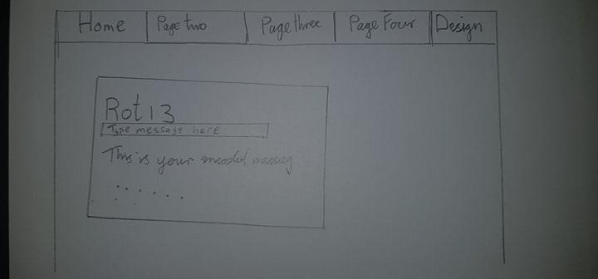

### Model 2:



### Model 3:



### Model 4:

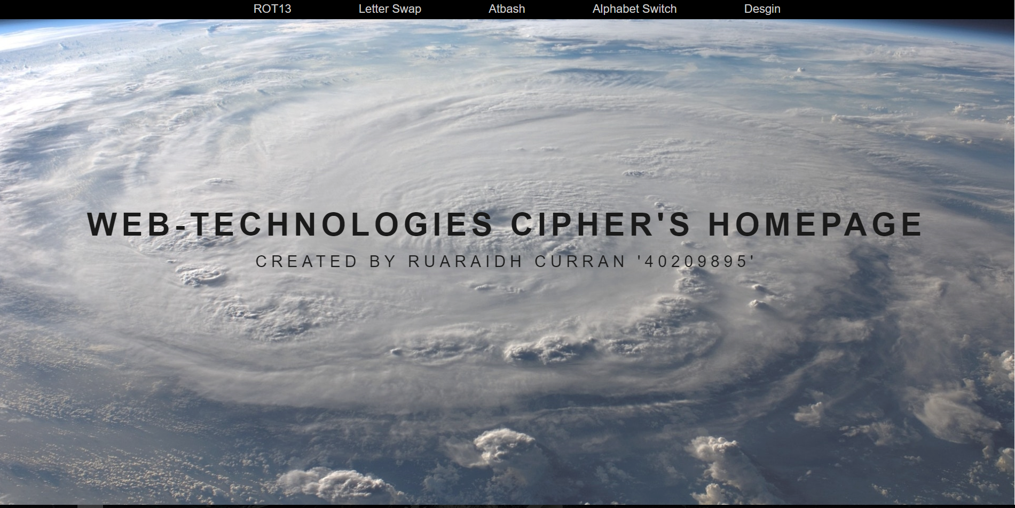

### Model 5:

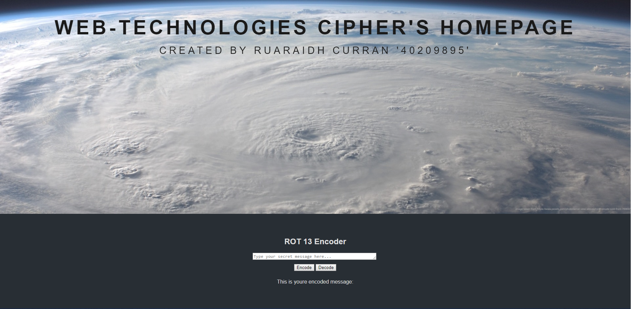

### Model 6:

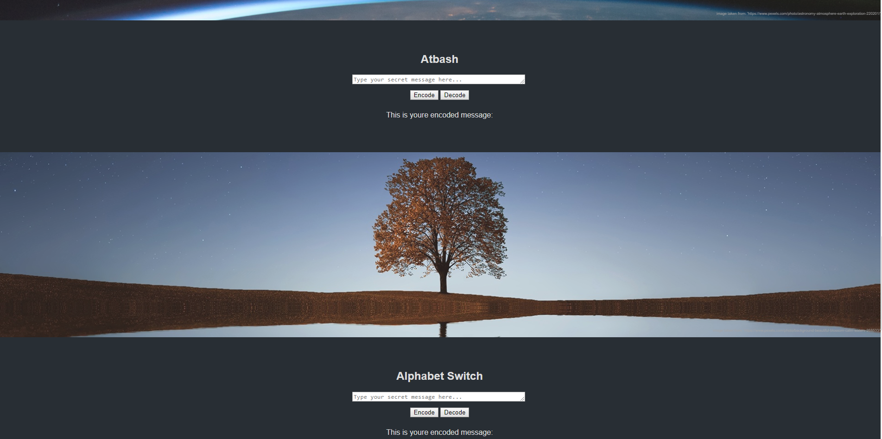

### Model 7:

